Spooky (or Spoopy) Season – B2 First

1. Describe and discuss:

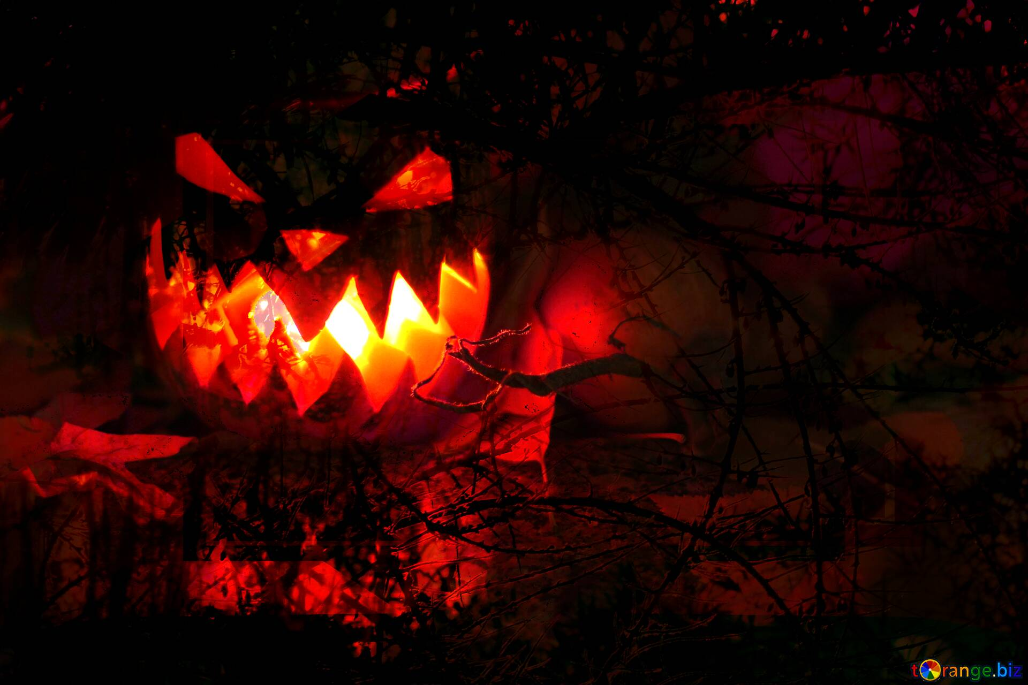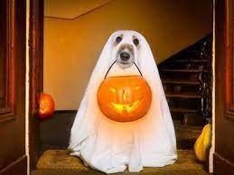

1. What are the similarities and differences between these two images?
2. Which of these images do you find the spookiest?
3. Reading and Use of English (Part 2)

Adapted from Merriam Webster – Words We're Watching

The Inside Poop On 'Spoopy'

Spoopy might startle people, especially around Halloween season. Perhaps it’s the resemblance (1) ______ spooky, which could lead you to believe the formation is nothing more (2) ______ a jaw-dropping typo. Or it could also be that it has poopy in it, which makes the spelling amusing to people (3) ______ enjoy bodily humour. This Internet sensation’s origin was a comical misspelling of the adjective *spooky* spotted on a department store's Halloween sign written in a "skeletal" font and photographed. The image was (4) ______ uploaded to the Internet; in short order, spoopy (5) ______ viral. Essentially, the word is used to describe something that typically would be spooky, (6) ______ an image of a skeleton or ghost, but is actually rather comical. The word has other connotations (7) ______ well: it is sometimes used for things that are intended to be spooky but simply fail to scare, or it could describe something that blends cuteness (8) ______ spookiness in a grotesque way.

1. Listening (Part 1) – VIDEO – [The Messed Up Origins™ of Jack-o’-Lanterns](https://youtu.be/nrPeUtjr9Uw)

*Watch the video (x2) until 5:17 and answer the following questions:*

1. According to the Youtuber’s previous views, why did people carve pumpkins?
   1. Because they wanted to scare others
   2. Because they didn’t like the taste of pumpkins
   3. Because there were too many pumpkins
2. Why did the devil go to see Stingy Jack?
   1. To take him to hell
   2. So that he could have some drinks with him
   3. Because he admired him
3. How did Stingy Jack avoid going to hell the first time?
   1. He trapped the devil in a silver cross
   2. He trapped the devil in his pocket
   3. He left the bar while the devil was paying
4. Why did the devil climb up a tree?
   1. Because Jack was hungry
   2. Because he was hungry
   3. Because Jack threatened him with crosses
5. The reason Jack wasn’t allowed in hell was…
   1. He wasn’t evil
   2. He made a deal with the devil
   3. God prohibited him from entering
6. What does the legend say?
   1. That Jack is happy because he escaped hell
   2. Jack wanders through purgatory with a pumpkin
   3. Jack’s spirit appears in marshes on October 31st
7. Language focus

*Watch the video again, complete the sentences below and match the words to their meanings:*

1. Well, it ___________ I was wrong about two things.
2. A voice comes out ___________ to be Satan himself.
3. Just ________ yourself ________ a silver coin.
4. Jack’s soul was sent down to hell where the devil was _________ waiting.
5. Was cursed to spend eternity __________ through the darkness or purgatory.
6. Wandering aimlessly through the forests and ____________

|  |  |
| --- | --- |
| 1. Turns out | 1. Walking around slowly with no clear purpose or direction |
| 1. Claiming | 1. In a way that shows a strong desire to do or have something |
| 1. Turn (sth/sb) into | 1. Saying that something is true or a fact |
| 1. Eagerly | 1. To be known or discovered finally and surprisingly |
| 1. Wandering | 1. Ground near a lake, a river, or the sea that is always wet |
| 1. Marshes | 1. To change, transform or develop from one thing to another |

|  |  |
| --- | --- |
| **USEFUL IDIOMS** | To be taken off guard  The lesser of two evils |